

Dr. Joseph, Paul inc.

2024-04-13

Dr. Paul

456 Thompson Port Apt. 291, South Madison, PR 54653

Phone: 7170398464

Fax: 4310722510

**Re:** Kimberly, Perez

**PHN:** 1391377581

**Birthdate:** 21-Oct-1996

**Address:** 80515 Phillips Crossroad Apt. 876, Michellebury, NH 43430

**Patient number:** 7766660497

To Whom It May Concern:

This is a medical letter to state the above patient is pregnant with expected delivery date of 01-May-2025. Hoping this information is satisfactory for your requirements.

Thank you.

Sincerely,

Dr. Joseph, Paul

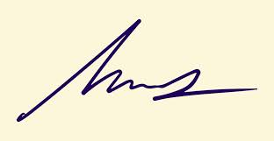

FRCS© NCMP

Clinical Assistant Professor, UBC

Department of Obstetrics and Gynecology SMH